Overview
There will be a maze in the map, which is randomly generated by Randomly Prim Algorithm. The drone should drive itself to the maze export. And, it is based on binocular vision.
Finished
Randomly Prim Algorithm (Dynamic Programming Solution)
It corresponds to “ObstacleMaker” part in the Gantt chart, is used to make a maze.
There is already an algorithm called Randomly Prim Algorithm to create a maze. Since it has an optimal substructure and the local solutions overlap, Dynamic Programming can be used, and sharply reduce the complexity of algorithm.
Demo:
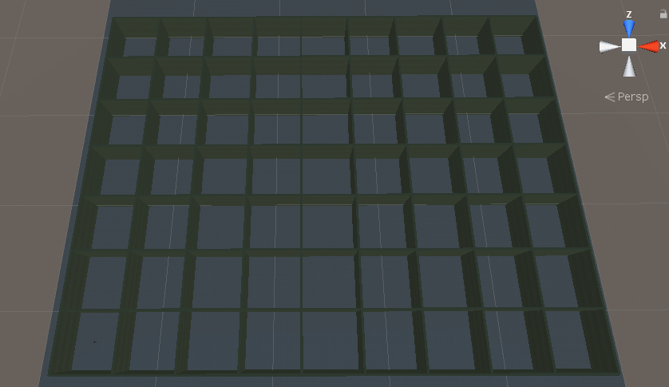
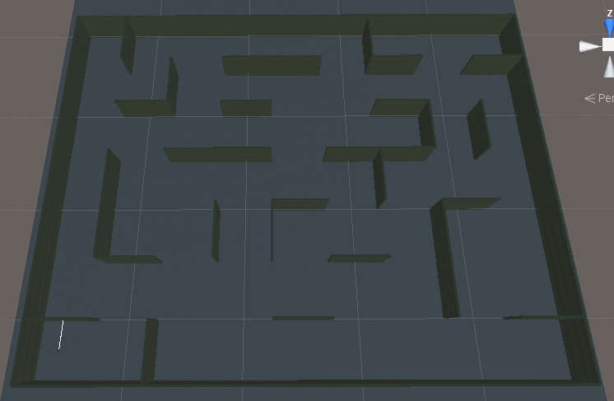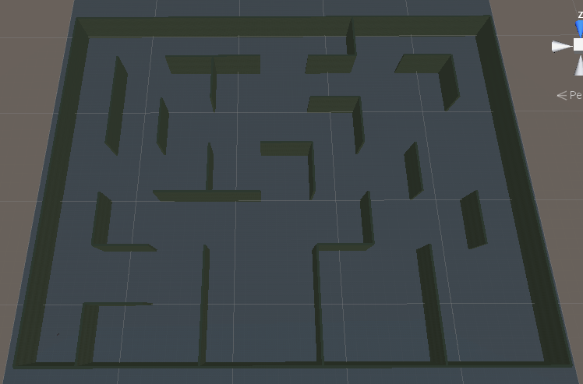

Distance and Disparity Inference (I think there is still room for improvement)
It corresponds to “StereoCamera” part in the Gantt chart.
I successfully calculate the distance from those two cameras’ baseline to the obstacle and disparity. However, it is inaccurate as the distance increased.
Demo:
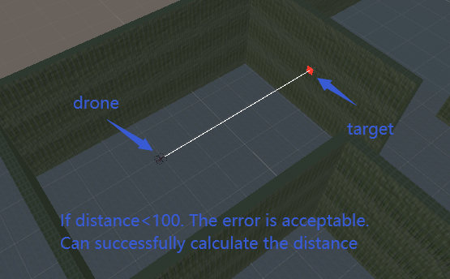
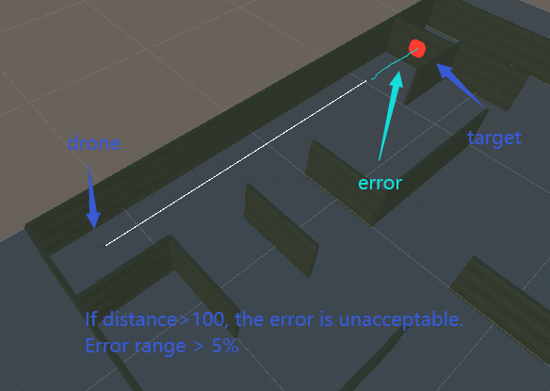
The table shows that the error is increasing with distance and disparity.
(Just five random samples. The relationship between actual distance and error is not a monotone increasing function.)
error | 0.4% | 0.8% | 3.3% | 8.2% | 36.3%
actual distance | 7.2 | 22.9 | 86 | 138.7 | 208
calculate distance | 7.17 | 23.1 | 83.2 | 150.1 | 283.5
disparity (in pixel) | 58 | 18 | 5 | 3 | 2
The main cause of errors is that the pixel value is integer and cannot be float. With the increase of distance, the disparity does not change even if the distance increases a lot.
(The error is unavoidable.)

($Distance= C*\frac{f*B}{d}$)$f$: focal length. $B$: baseline. $d$: disparity. C: coefficient.
Basic UI Logic
It corresponds to “InterfaceManager” part in the Gantt chart.
Contains lot of code, but low-tech.
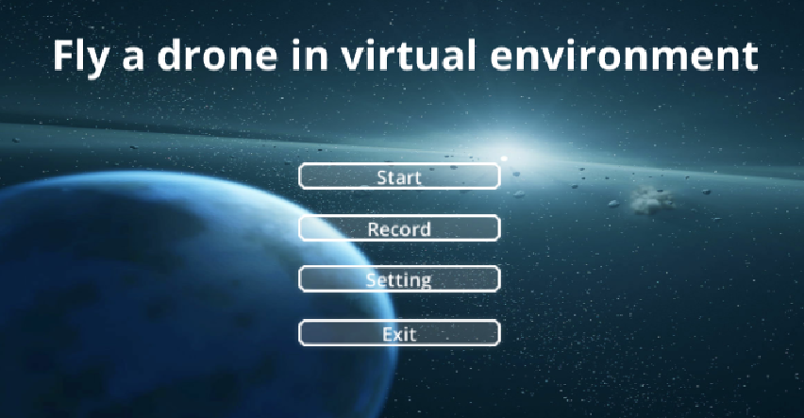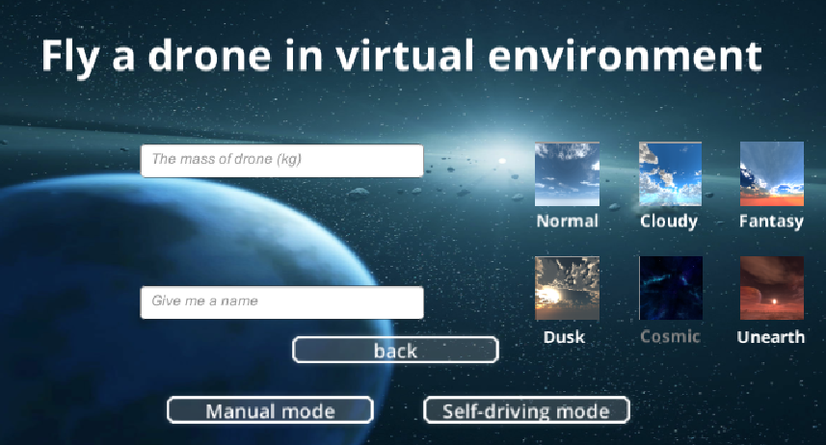
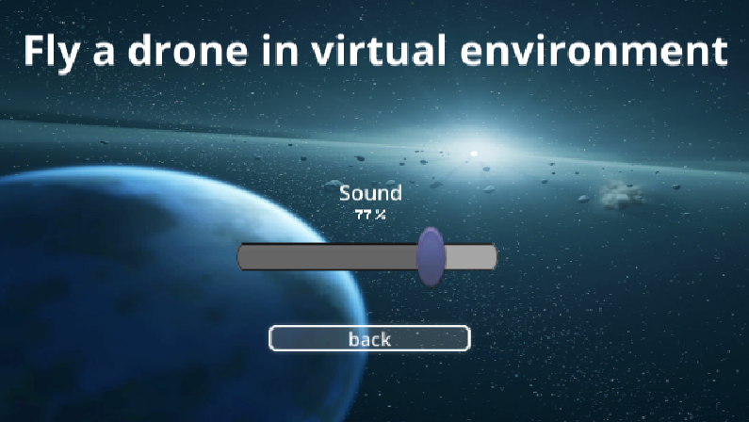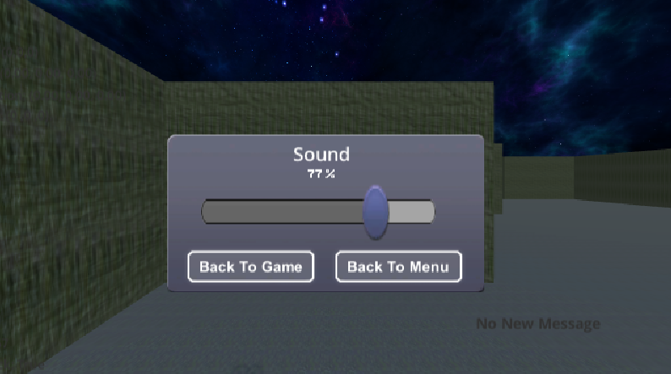

Basic Physical Logic
It corresponds to “DroneController” part in the Gantt chart.
The drone would tilt if forces applied.
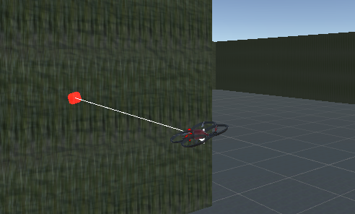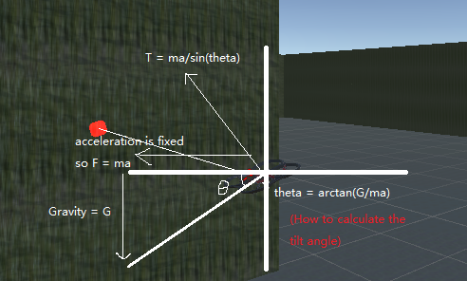
It's just an approximation here. In fact, if θ is big enough, the formula here will fail. I set an upper bound for the angle with 23 degrees.

Further Plan
Path Programming
I would use Heuristic RRT Algorithm, because compare with Dijkstra Algorithm and A star. RRT is more suitable in the case that there is no global map. However, the rate of convergence is going to be slow.
I consider improving convergence speed of RRT in a heuristic way. Introduce a cost function like what we do in A star. It is just a preliminary idea now.
Improve my Distance Inference Algorithm
I just use SSD image matching algorithm to find ROI. It is a 3-dimensional search with high complexity. There is a way to translate to a 2-dimensional searching on an Epipolar Line. It involves knowledge of Epipolar Geometry and fundamental matrix. It is a big challenge.
By the way, in virtual environments such as Unity. It is not needed to consider camera distortion. It may be easier to find the fundamental matrix.
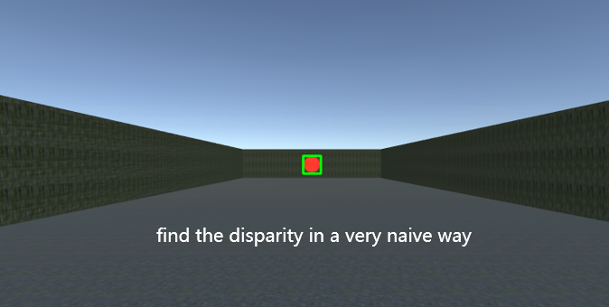
Gantt Chart
